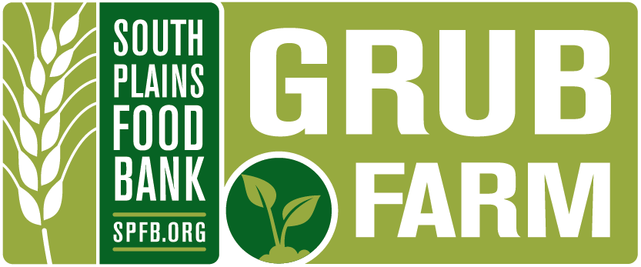
Share of the Harvest: Community Supported Agriculture

GRUB
The GRUB Program (Growing Recruits for Urban Business) provides area youth with life, job, and leadership skills through the management of the 5-acre Carolyn Lanier Youth Farm.

Share of the Harvest
The price of a share is the total cost incurred in producing the harvest divided by the estimated number of shares. To streamline the operations and purchases of seed, supplies, and equipment, shareholders will pay the full amount at the beginning of the farming season.

When fully developed, the GRUB Farm can accommodate approximately 100 shares. Sign-up will be on a first come, first served basis. The essential ingredient in all of this is commitment. The GRUB youth are committing to the work; in return, your commitment provides the capital at the time it is needed to grow your food and provide the youth with a summer job.

Space for current year shareholders will be reserved until March 1, 2021.

Please keep in mind that this is a farming venture and with any farming venture certain risks are present. The main risks are weather and pests. As a shareholder in our farm you take on the same risk as the farmer. We do not offer a refund if produce is not as bountiful as anticipated.

Pick up on Thursdays from 7:00 a.m. – 4:00 p.m.
Fridays 7:00 a.m. – 4:00 p.m.
Pickup at 304 76th – corner of 76th and Ave B.

Season is approximately June through October.
Shareholders are notified by email when produce distribution begins.

For more information, contact Matthew McEwen 806-778-7346, mmcewen@spfb.org

