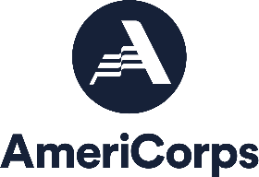
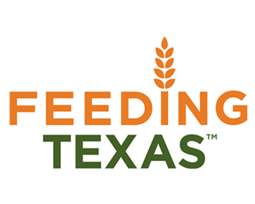
South Plains Food Bank, Inc

Position: Community Capacity Corps - SPFB Community Impact Summer Associate
Locations : Lubbock, TX
Service Dates: June 9, 2022 – August 17, 2022
Application Deadline: May 20, 2022

Feeding Texas leads a unified effort for a hunger-free Texas. Summer Associate VISTAs will work on the front lines in the fight against hunger by supporting innovative programs focused on alleviating the upstream causes and downstream effects of food insecurity.

As the Community Impact Summer Associate, you will help the South Plains Food Bank fight hunger in West Texas by providing logistical support for the Food Distribution Program.

Duties & Responsibilities
- Assist prospective current Clientele with enrollment with Food Assistance.
- Follow up with clients regarding their Food Assistance application at point of approval or denial.
- Maintain client records within the Charity Tracker data base of all client contacts and information.
- Work in conjunction with all staff to maximize relationships with current and potential partners.
- Assists CARE Unit in speaking to clients at their vehicle.
- Performs other duties as assigned.

Program Benefits
- Choice of Education Award or Cash Stipend upon completion of Service
- Living Allowance

Qualifications
- Access to reliable transportation, personal vehicle recommended.
- Minimum 18 years of age
- Responsible for finding own housing

Work Schedule: Monday—Friday 8 hours daily / 40 hours weekly (8:00am—4:30pm)

Contact Ruby Leal Sanchez at (806) 763-3003 Ext: 139 or rsanchez@spfb.org

Please apply directly at:
Indeed.com
Spfb.org/careers

