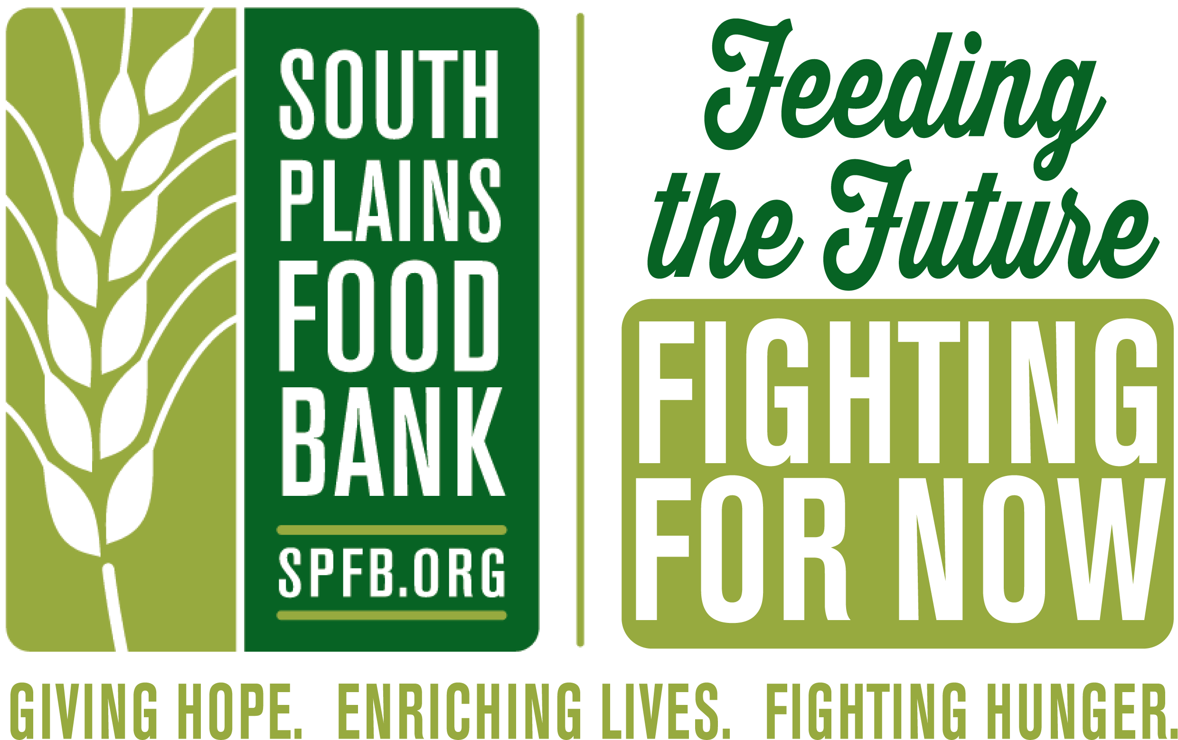
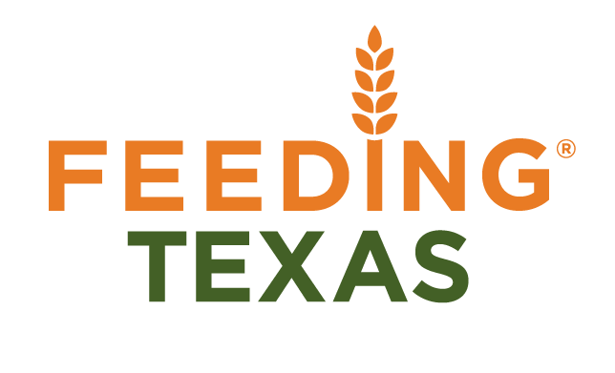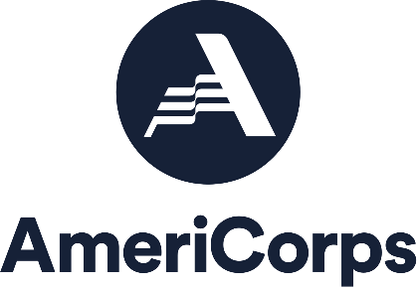

Position: Community Impact VISTA
Locations: South Plains Food Bank, Lubbock TX
Service Dates: July 2022- July 2023

Feeding Texas leads a unified effort for a hunger-free Texas. We assist hungry Texans through a statewide network of twenty-one food banks, lead the public discussion on hunger in Texas, and strengthen the anti-hunger movement through collaboration and capacity-building. The Community Capacity Corps is made up of a creative and motivated team focused on alleviating the upstream, economic causes of hunger as well as the downstream effects of hunger on health. VISTAs build non-traditional partnerships to increase community access to new services, and strategically incorporate the voices of hungry Texans into the public conversation on hunger through StoryBank Texas and community feedback loop projects. With ample coaching and personal development opportunities, our corps offers emerging non-profit professionals a way to gain a level of experience above other entry-level positions. Collaborate with other VISTAs and non-profit professionals in a variety of positions, while building a foundation for a meaningful career.
As a Community Impact VISTA, you will work closely with the Agency Services/CARE Unit team at the South Plains Food Bank to expand health partnerships and food access to rural areas. You will also facilitate client empowerment strategies through satisfaction surveys and the implementation of next steps gleaned through those survey results. The VISTA will also engage community members through one-on-one interviews in order to gather stories for a statewide StoryBank with a focus on learning about the authentic lives of people experiencing food insecurity and presenting the truth of hunger in our community to a public audience.
Program Benefits
- Childcare Assistance if Eligible
- Relocation Allowance
- On-Going Training and Professional Development
- Choice of Health Benefit or Healthcare Allowance
- Choice of Education Award ($6,495) or Cash Stipend ($1,800) upon completion of 1 Year of Service
- Living Allowance of $1,100 - $1,300/month pre-taxes (based on service site)
- Professional Development Fund
Qualifications
- College Graduate or equivalent experience
- Interest in innovative approaches to addressing poverty
- Access to reliable transportation, personal vehicle recommended
- Excellent written and verbal communication skills
- Minimum 18 years of age
- Responsible for your own housing

To apply, send your resume and cover letter describing how your interests and skills align with the goals of the program to Leon Jones, VISTA Program Manager at ljones@feedingtexas.org or apply directly at https://my.americorps.gov/mp/listing/viewListing.do?id=74075&fromSearch=true

