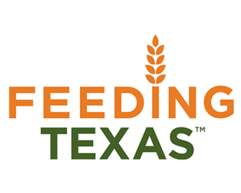
South Plains Food Bank, Inc.

Position: Community Capacity Corps - SPFB GRUB Summer Associate
Locations : Lubbock, TX
Service Dates: June 9, 2022 – August 17, 2022
Application Deadline: May 20, 2022

Feeding Texas leads a unified effort for a hunger-free Texas. Summer Associate VISTAs will work on the front lines in the fight against hunger by supporting innovative programs focused on alleviating the upstream causes and downstream effects of food insecurity.

As the GRUB Summer Associate, you will help the South Plains Food Bank provide life skills and job training to young adults using the food bank’s farm and community garden through the Growing Recruits for Urban Business Program.

Duties & Responsibilities:
- Educate and mentor a diverse youth population in the GRUB Summer Program.
- Lead and assist (work side-by-side) with a team of GRUB student interns as they do field work (harvesting, weeding, planting, and other duties).
- Assist FOG (Farm, Orchard, GRUB) staff in conducting teambuilding, leadership, and other educational classes.
- Must set a good example for GRUB student interns through action and words. This includes reporting to work on time, exemplary attendance and a good work ethic.
- Work with other VISTA Summer Interns to plan activities for GRUB student interns.

Program Benefits
- Choice of Education Award or Cash Stipend upon completion of Service
- Living Allowance

Qualifications
- Access to reliable transportation, personal vehicle recommended.
- Minimum 18 years of age
- Responsible for finding own housing
Work Schedule: Monday—Friday 8 hours daily / 40 hours weekly (8:00am—4:30pm)

Contact Ruby Leal Sanchez at (806) 763-3003 Ext: 139 or rsanchez@spfb.org

Please apply directly at:
Indeed.com
Spfb.org/careers

