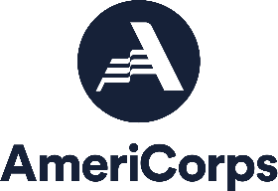
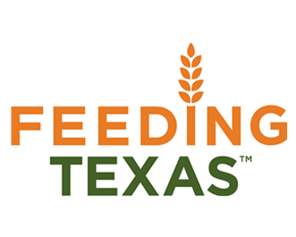
South Plains Food Bank, Inc

Position: Community Capacity Corps - SPFB Kitchen Summer Associate
Locations : Lubbock, TX
Service Dates: June 9, 2022 – August 17, 2022
Application Deadline: May 20, 2022

Feeding Texas leads a unified effort for a hunger-free Texas. Summer Associate VISTAs will work on the front lines in the fight against hunger by supporting innovative programs focused on alleviating the upstream causes and downstream effects of food insecurity.

As the Kitchen Summer Associate, you will help the South Plains Food Bank provide food and services to people experiencing food insecurity in West Texas.

Duties & Responsibilities:
- Provide assistance to the Director and Kitchen of Hope Team.
- Assist with the preparation of hot food and snacks for daily service using provided recipes and prep sheets.
- Perform kitchen duties including cutting, slicing, panning and cooking of food items.
- Assist with cleaning duties including mopping floors, maintaining kitchen equipment and taking out garbage.
- Assist the Catering Specialist with events.
- Assist Administrative Assistant with clerical work when needed.
- Assist KOH staff with routes, unloading and loading (no driving).

Program Benefits
- Choice of Education Award or Cash Stipend upon completion of Service
- Living Allowance

Qualifications
- Access to reliable transportation, personal vehicle recommended.
- Minimum 18 years of age
- Responsible for finding own housing

Work Schedule: Monday—Friday 8 hours daily / 40 hours weekly (8:00am—4:30pm)

Contact Ruby Leal Sanchez at (806) 763-3003 Ext: 139 or rsanchez@spfb.org

Please apply directly at:
Indeed.com
Spfb.org/careers

